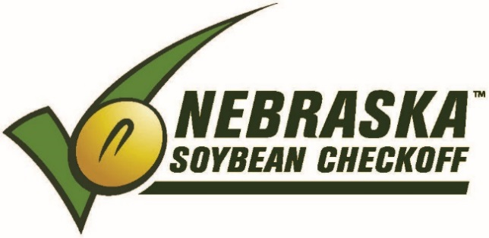

NEBRASKA SOYBEAN BOARD MEETING
September 5, 2018

Country Inn & Suites / (402) 476-5353
5353 North 27th St.
Lincoln NE 68521

WEDNESDAY – September 5, 2018 / (Meeting - Omaha Room)
Breakfast (hotel guests - complimentary hotel breakfast)
7:30 a.m. Call to Order – Tony Johanson
Roll Call – Terry Horky

7:35 a.m. Agenda Approval

7:37 a.m. Minutes Approval / July 2018

7:40 a.m. Financial Report – Lois Ronhovde

7:45 a.m. Correspondence

7:50 a.m. FY19 Opportunities (10 min. presentation + 10 min. Q & A)
- 7:50 a.m. - ZOOM Connect-UNL – Rick Rasby
- 8:10 a.m. - USAPEEC – Mary Alice Shreve, Mgr. of Allied Industry Relations
- 8:30 a.m. - Soybean Row Spacing and Nitrogen Management-UNL – Strahinja Stepanovic
- 8:50 – 9:30 a.m. - Farm Market iD Farm Focus Software (Conf Call) – Cale
9:30 a.m. Information Reports
- UNL – Hector Santiago, George Graef, David Hyten
- USB – Mark Caspers, Gregg Fujan, Mike Korth, Ed Lammers
- ASA – Ken Boswell, Dennis Fujan
- NSA – Robert Johnston

10:00 a.m. Break
10:15 a.m. Recess for Committee Meetings
- Research – Larry Tonniges
- International Marketing – Greg Anderson

10:45 a.m. Committee Meetings
- Producer Education/Communications – Anne Meis
- Domestic Marketing – Rich Bartek

11:15 a.m. Reconvene for Committee Reports and Motions
- Research – Larry Tonniges
- Producer Education/Communications – Anne Meis
- Domestic Marketing – Rich Bartek
- International Marketing – Greg Anderson

12:00 p.m. Lunch (Capitol Room)

1:00 p.m. Strategic Business Plan Updates – Victor Bohuslavsky

1:30 p.m. Old Business
- #108 FY19 Proposal - Farm Market iD Farm Focus Software – Cale Buhr
- FY18 Auditing Firm Selection (BMG, Buckley Sitzman) – Lois Ronhovde
- Election Results – Victor Bohuslavsky
- USB Director Advertising FY19 – Victor Bohuslavsky (1 seat – Gregg Fujan)
- Districts up for FY19 Election – Victor Bohuslavsky (#2, #4, #8)

1:45 p.m. New Business
- #114 FY19 Proposal - Strategic Business Plan-Phase II part 2,3 – Leadership Resources
- #120 FY19 Proposal - Nebraska Soybean Board Election Budget – Victor Bohuslavsky
- #1600 FY19 Proposal - Western Region Administrative Services – Victor Bohuslavsky
- FY19 Operations Budget
- FY19 NSB Budget Approval
- November Board Meeting - November 19-20, 2018 / Cornhusker Marriott, Lincoln NE
- Staff Review
2:15 p.m. Executive Session

2:45 p.m. Adjourn

