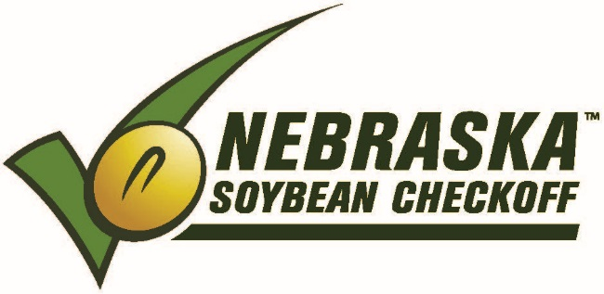

NEBRASKA SOYBEAN BOARD MEETING
July 9-10, 2018

Pheasant Bonanza Lodge / (402) 374-1765
3097 County Rd O
Tekamah, NE 68061
From Tekamah NE, go west on Hwy 32 (4 miles)
Turn right on County Road 29. (6 ½ miles)
Turn right on County Road O.
Pheasant Bonanza Hunt Club & Kennel / On top of hill
From Oakland NE, go north on Hwy 77. (3 ½ miles) Turn right on County Road O. (9 ½ miles) Pheasant Bonanza Hunt Club & Kennel / On top of hill

Directions: (aprx on miles) See attached map
From Tekamah NE, go north on N 13th St/US-75 N toward P St.
Turn left onto County Road P.
Turn left onto County Road 32.
Take the 1st right onto County Road O.
Pheasant Bonanza Hunt Club & Kennel / On top of hill

MONDAY - July 9, 2018 / (Meeting Room – Ringnecks / Bldg North of Lodge)
12:00 p.m. Lunch (Lodge Restaurant)

12:45 p.m. Call to Order – Tony Johanson
Roll Call – Terry Horky

12:47 p.m. Agenda Approval

12:48 p.m. Minutes Approval / March 2018

12:50 p.m. Financial Report – Lois Ronhovde

12:55 p.m. Correspondence

1:00 p.m. Review Strategic Business Planning – Alex Garcia, Leadership Resources

1:45 p.m. Information Reports
- UNL – Hector Santiago, George Graef, David Hyten
- USB – Mark Caspers, Gregg Fujan, Mike Korth, Ed Lammers
- ASA – Ken Boswell, Dennis Fujan
- NSA – Robert Johnston
2:15 p.m. FY19 Opportunities (10 min. presentation + 5 min. Q & A)
- 2:15 p.m. - FY18 CY Thompson Messaging – Doug Carr, UNL Foundation
- 2:30 p.m. - Ag in the Classroom – Megahn Schafer, NE Farm Bureau Foundation
- 2:45 p.m. - National Biodiesel Board – Tom Verry (30 minutes)

3:15 p.m. Recess for Committee Meetings
- Producer Education/Communications – Anne Meis
- Domestic Marketing – Rich Bartek

5:00 p.m. Committee Meetings
- Research – Larry Tonniges
- International Marketing – Greg Anderson

6:30 p.m. Recess for Dinner
7:00 p.m. NSB Dinner / Silver Hills Vineyard – 3130 County Road M, Tekamah, NE 68061 / (402)374-1602

TUESDAY - July 10, 2018
Breakfast
7:30 a.m. Reconvene Nebraska Soybean Board Meeting
7:31 a.m. Further Discussion on FY19 Project Proposals
Committee Reports and Motions
- Research – Larry Tonniges
- Producer Education/Communications – Anne Meis
- Domestic Marketing – Rich Bartek
- International Marketing – Greg Anderson

10:00 a.m. Break
10:15 a.m. Agriculture and Water Center of Excellence – Susan Green (10 min. presentation + 5 min. Q & A)
10:30 a.m. Review Strategic Business Planning – Board, Staff
11:00 a.m. Old Business
- District Board Member Elections – Victor Bohuslavsky

11:05 a.m. New Business
- Selection of FY18 Auditor – Lois Ronhovde
- September Board Meeting / September 4-5, 2018 – Lincoln NE
- November Board Meeting / November 19-20, 2018 – Lincoln NE

11:30 a.m. Adjourn / Lunch (Lodge Restaurant)

