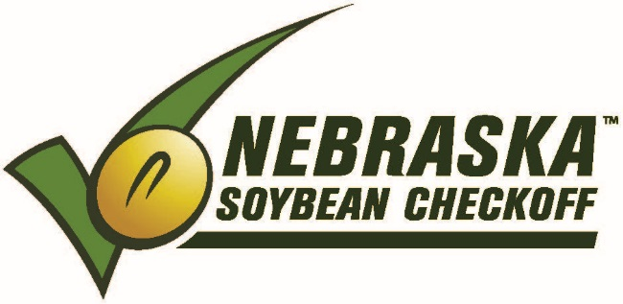

NEBRASKA SOYBEAN BOARD MEETING
March 13-14, 2018

Embassy Suites / (402) 474-1111
1040 P Street
Lincoln, NE 68508

TUESDAY – March 13, 2018

Research Advisory Committee Meeting / (Regents A Room)
Breakfast (hotel guests-complimentary hotel breakfast)
8:30 a.m. Research Advisory Committee Meeting – Tonniges
11:30 a.m. Conclude Research Advisory Committee Meeting
11:35 a.m. Lunch / Atrium Area

NSB Board Meeting / (Regents A Room)

12:30 p.m. Call to Order – Tony Johanson
Roll Call – Terry Horky

12:32 p.m. Agenda Approval

12:33 p.m. Minutes Approval / January 2018

12:35 p.m. Financial Report – Lois Ronhovde

12:40 p.m. Correspondence

12:40 p.m. FY18 Opportunities (10 min. presentation + 10 min. Q & A)
- 12:40 p.m. – Husker Sports Media – Karen Brokaw & Angie Ness, Brokaw Marketing
- 1:00 p.m. – Ag Sack Lunch Program Update – Karen Brokaw, Brokaw Marketing
- 1:20 p.m. – NPPA Funded Project Updates – Kyla Habrock, NPPA
- 1:40 p.m. – East Campus Student Commons Project – Doug Carr, UNL Foundation
2:00 p.m. UNL Researcher Reports (10 min. presentation + 5 min. Q & A)
- 2:00 p.m. – Improve Soybean Resistance to Nematodes w/Synthetic RNA Interference–Bin Yu
- 2:15 p.m. – SCN Education Update – Loren Giesler
- 2:30 p.m. – Ubiquitination System – Lirong Zeng

2:45 p.m. Break

3:00 p.m. Recess for Committee Meetings
- Producer Education/Communications – Anne Meis
B. Domestic Marketing – Rich Bartek

3:30 p.m. Recess for Committee Meetings
A. Research – Larry Tonniges
B. International Marketing – Greg Anderson

5:00 p.m. Recess Meeting

WEDNESDAY – March 14, 2018
7:30 a.m. Reconvene for Committee Reports and Motions
- Research – Larry Tonniges
- Domestic Marketing – Rich Bartek
- Producer Education/Communications – Anne Meis
- International Marketing – Greg Anderson

9:30 a.m. Strategic Business Planning – Alex Garcia, Leadership Resources

10:15 a.m. Break

10:30 a.m. Information Reports
- UNL – Soybean Management Field Days – Keith Glewen
- UNL – Hector Santiago, George Graef, David Hyten
- USB – Mark Caspers, Gregg Fujan, Mike Korth, Ed Lammers
- ASA – Ken Boswell, Dennis Fujan
- NSA – Robert Johnston

11:00 a.m. Old Business
- Districts #1, #3, #6 Elections – Victor
- July Board Meeting / July 9-10, 2018 – Pheasant Bonanza Lodge-Tekamah, NE
11:05 a.m. New Business
- Victor’s Travel to USB Meeting in Omaha, NE / July 16-19, 2018
- NE Public Service Commission Contract Renewal – Lois
- #114 Strategic Business Plan Proposal-Phase I & Phase II part 1 - Leadership Resources

11:10 a.m. USB Nomination Interviews – Victor

12:00 p.m. Adjourn / Lunch

